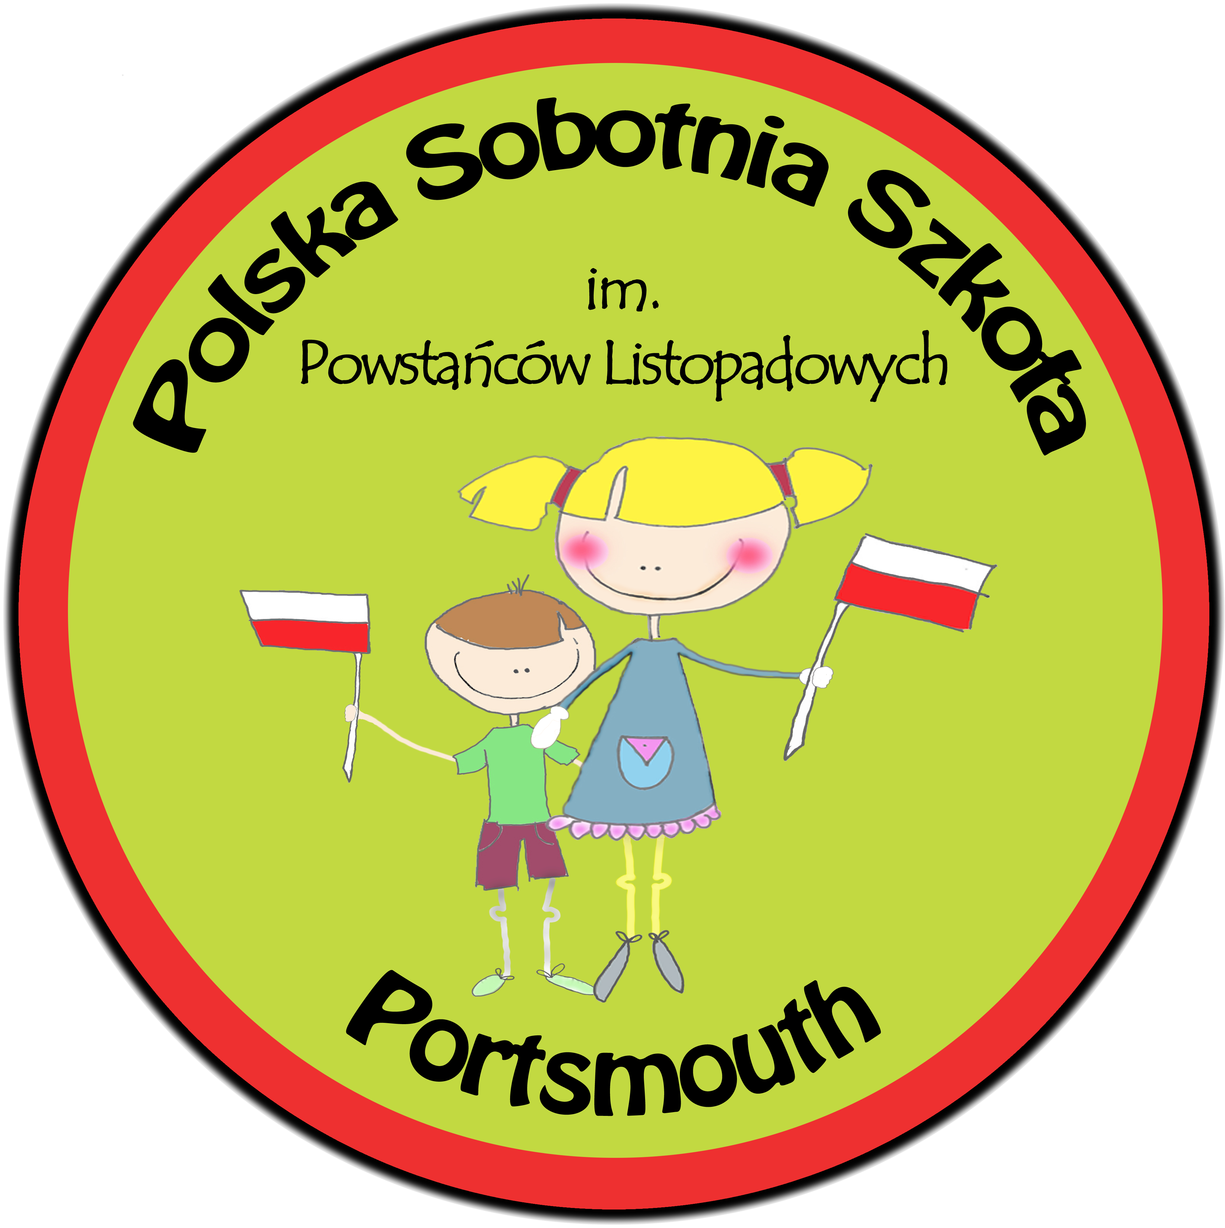
THE POLISH COMMUNITY SCHOOL PORTSMOUTH

The Polish Community School
c/o The Portsmouth Academy,
St Mary’s Road, Portsmouth, PO1 5PF

Tel: 07447 911300
Email: info@polskaszkolaportsmouth.co.uk
Web: www.polskaszkolaportsmouth.co.uk

Annual General Meeting
Polish Community School, Portsmouth
SATURDAY 29th FEBRUARY 2020 @ 1.10pm in the upstairs library
@ Portsmouth Academy, St. Mary's Rd, Portsmouth PO1 5PF

AGENDA

1. Welcome.

2. Appointment of Chairman and minute-taker for the meeting.

3. Approval of the proposed agenda.

4. Minutes of the last AGM.

5. Director's annual report.

6. Presentation of annual accounts 2018/19.

7. Approval of independent examiner for accounts 2019/20.

8. Resignation of trustees.

9. Election of charity trustees, chairman, secretary and treasurer.

10. Any other business.

Parents are encouraged to submit any questions they would like to raise at the meeting in advance, in writing, to the Director by email at info@polskaszkolaportsmouth.co.uk

